Our topic this half term is …

The Vikings and The Anglo Saxons

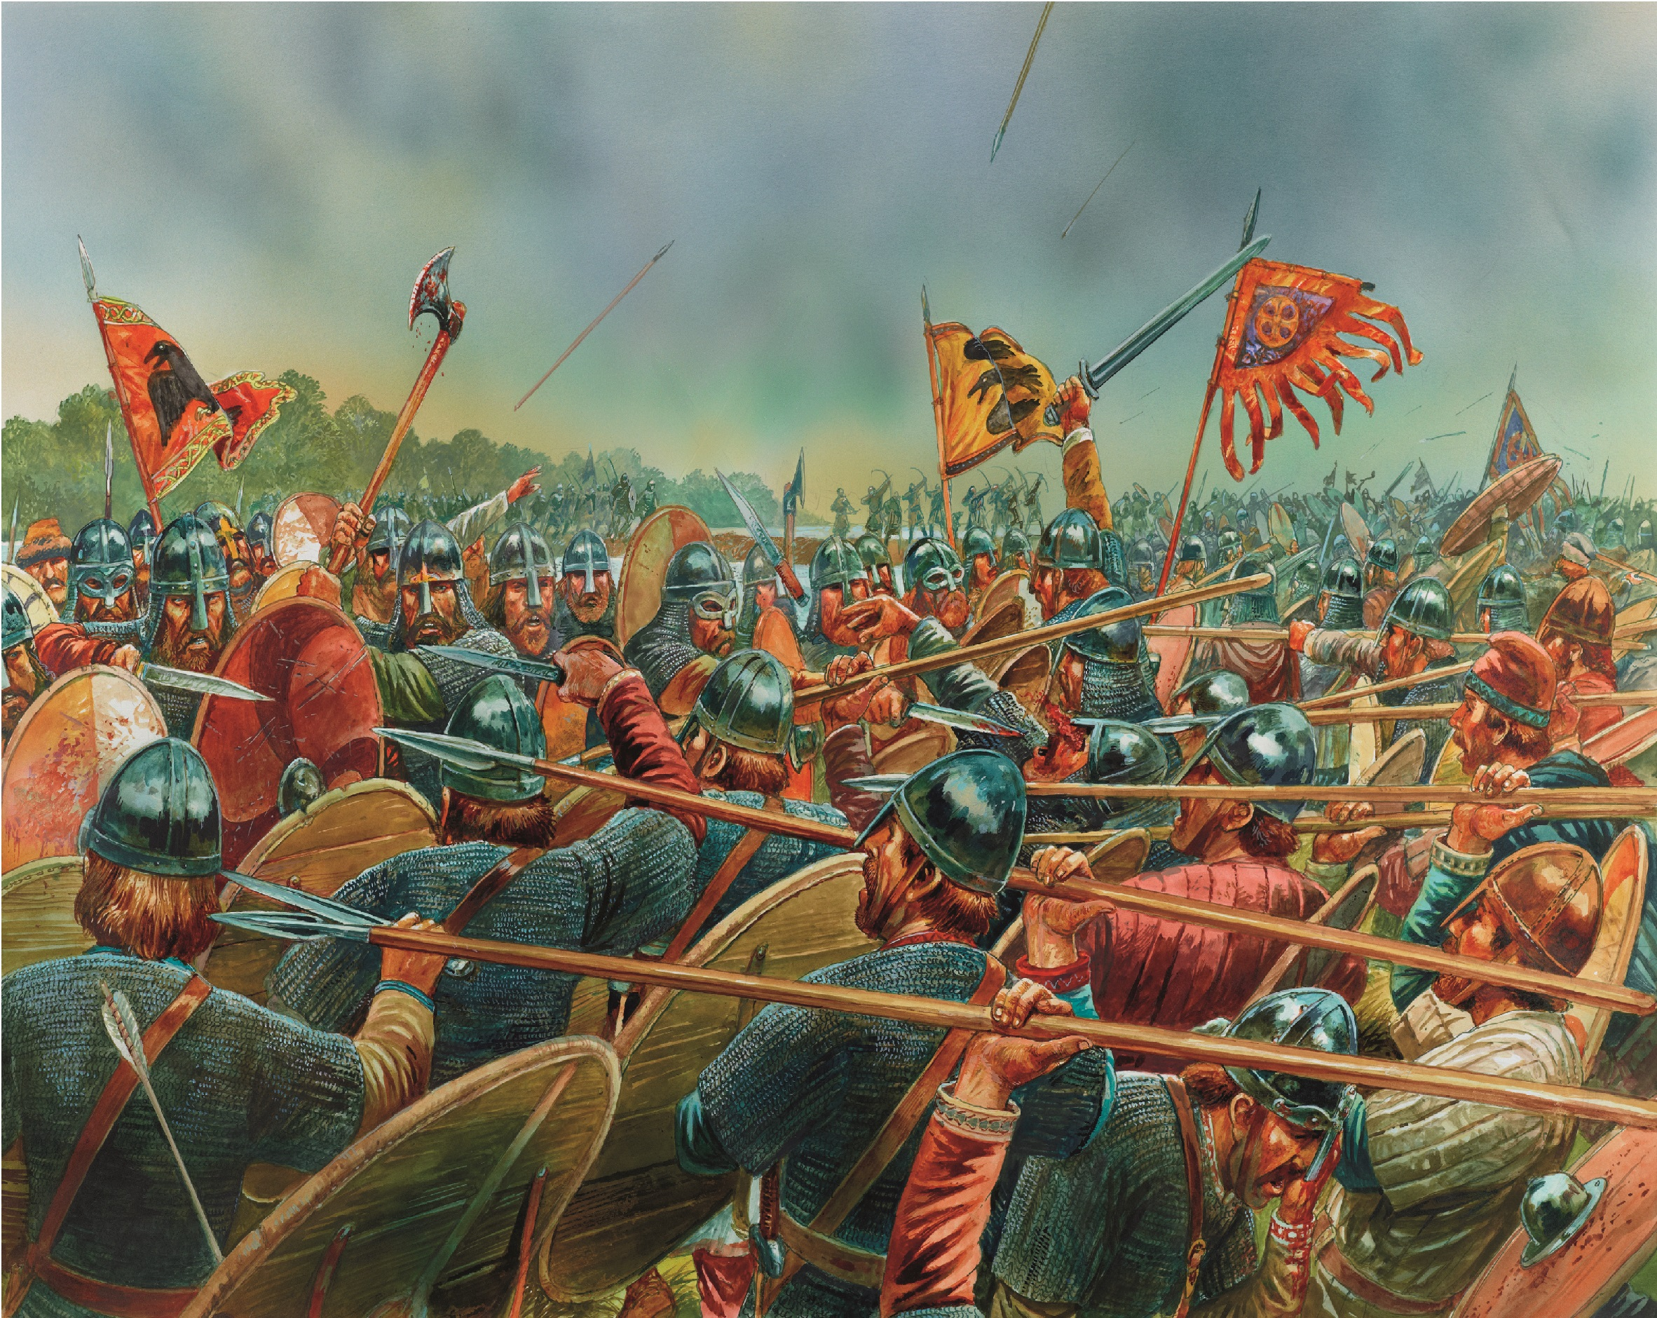

Week 1 – Design a vocabulary poster for children who are focusing on this topic. Explain word meanings, using images for clarity.

Week 2 – Research King Alfred the Great. Write a character description with the facts that you have learned.

Week 3 – Learn and rehearse the Anglo-Saxons Days of the week. Design a poster to show your understanding.

Week 4 – Explore life in Danelaw.

Week 5 – Design your own timeline of the important dates that lead up to the end of the Viking age.

Week 6 –Research Anglo Saxon Gods. Draw and label them, explaining who they are and why they are importance

Your homework is due in on Friday 12th February.

I am looking forward to seeing your extending learning and great ideas!