Our topic this half term is …

World War II

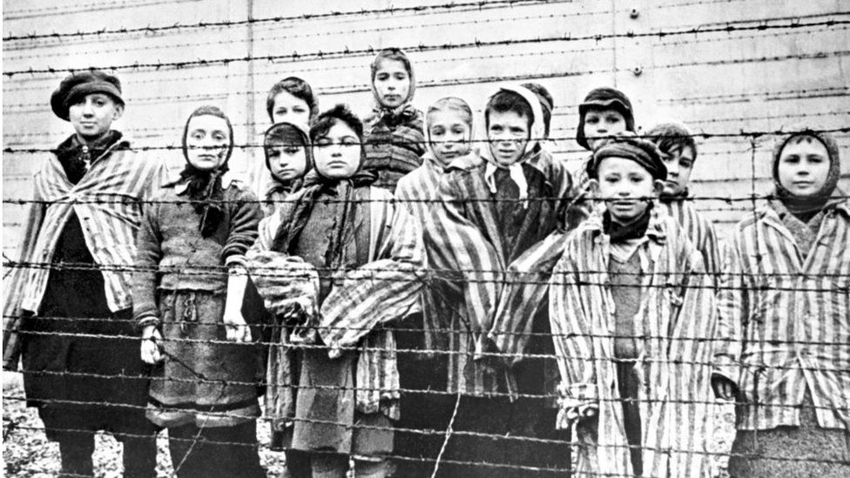

Week 1 – Design a vocabulary poster for children who are focusing on WW II. Explain word meanings, using images for clarity

Week 2 – Research ‘The Star of David’, looking at the reason for the people in the concentration camps wearing the badges. Draw and design your own ‘Star of David’. Think carefully about symbols or words you might want to add on the star.

Week 3 – Write a recount of the first time Bruno and Shmuel met at the fence. Include emotions, figurative language and a range of conjunctions to demonstrate the friendship between them.

Week 4 – Research victims of the Holocaust and create a ‘memorial’ booklet, using key information that you discover.

Week 5 – Write a fictional diary of an evacuee child during WW2, including experiences and relationships. Remember to use diary features here!

Week 6 – Research Anne Frank and create a fact file based on her life

Your homework is due in on the week beginning 14th December. I hope you have lots of fun learning about our topic this half term. I look forward to seeing all of your hard work.