Literacy Policy

St John’s Catholic Primary School
Mission Statement

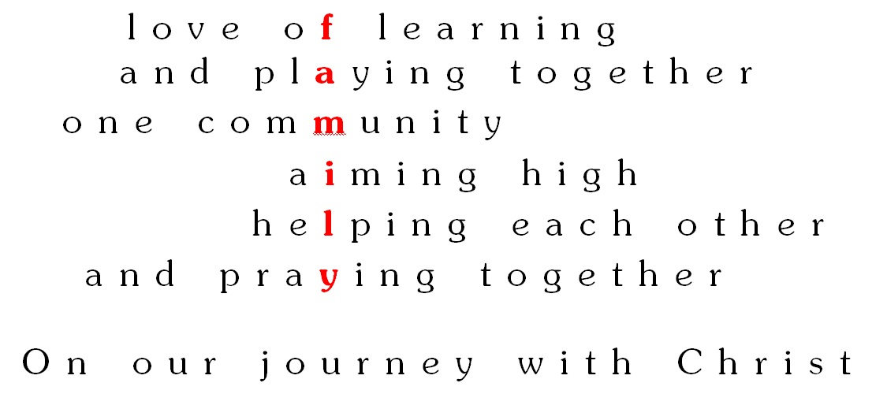

The aim of this policy is to guide teachers and support staff in providing the best possible learning experiences for our children. We believe that every child is a child of God; we will encourage in all children the knowledge and love of God, and in a concern and care for others; we will value each child for who they are and what they are; and we will ensure that every child has the opportunity to become the person God knows them to be, irrespective of their starting points, background or cultural and religious beliefs.

Our mission sets out our commitment to ‘aiming high’. Improvements in the quality of teaching and learning are brought about through a process, which involves:

- reflection by individual professionals
- acting on planning feedback and guidance
- use of assessment data
- the target setting process
- sharing in-house expertise through
  - joint/team planning
  - discussion with colleagues, subject coordinators and SLT
  - Staff training at school
  - Team teaching lessons
  - Peer observation and lesson studies
- implementation of recommendations arising from classroom observation
- effective response to guidance from advisers and implementation of OfSTED Action Plan
- CPD courses

This policy will be reviewed regularly to enable us to take account of new initiatives, curriculum changes, technological developments and any changes to our pupil cohort profile.

Aims and Objectives

By the end of key stage 2, at St John’s Catholic Primary School, we strive for all of our children to:

· be effective, competent communicators and good listeners;
· express opinions, articulate feelings and formulate responses to a range of texts both fiction and non-fiction using appropriate technical vocabulary;
· foster an interest in words and their meanings, and to develop a growing vocabulary in both spoken and written form;
· have a great interest and passion for books and to read for enjoyment, engaging with and understanding a range of text types and genres;
· be able to write in a variety of styles and forms showing awareness of audience and
purpose;
· develop powers of imagination, inventiveness and critical awareness in all areas of literacy;
· use grammar and punctuation accurately;
· understand spelling conventions;
· produce effective, well-presented written work.

Teaching and Learning

Statutory requirements for the teaching and learning of English are laid out in the 2014
National Curriculum, and in the Communication, Language and Literacy section of the Early
Years Foundation Stage (2014).

In order to best meet the needs of our pupils, we use a variety of teaching and learning styles in our Literacy lessons. We provide some whole class teaching alongside opportunities for small groups to work with the teacher or teaching assistant. Some children may work with an adult to improve their understanding, and some may work with an adult to face more of a challenge in a lesson that they havea firm understanding in.

Our principal aim is to develop children’s knowledge, skills and understanding in language, reading and writing. At St John’s Catholic Primary School, we do this through a daily lesson, where we adapt our teaching styles to suit the needs of the individual child. Throughout the week, there are daily phonics lessons for Foundation Stage and KS1 children and any children in KS2 that need continued phonics support.

In all classes children have a wide range of literacy abilities. We recognise this fact and provide suitable learning opportunities by matching the challenge of the task to the ability of the child. We achieve this through a range of strategies. Working walls are used to support children in their learning and to encourage independence within the classroom. Children requiring additional support receive this through small group sessions within lessons, work which is differentiated to meet their ability and through interventions planned by the class teacher and delivered by either the class teacher or teaching assistants.

Teaching phonics

At St John’s Catholic Primary School we follow letters and sounds. Children are placed into the phonics group which is best for them, depending on which phase they are up to, and teachers and teaching assistants teach these phonics groups. These teaching sessions are around 20-30-minutes, each day, 5 times per week.

Teaching guided reading

Guided reading is extremely important at St John’s Catholic Primary, and it is where teachers take the time to thoroughly discuss vocabulary, ask ability appropriate questions, support children that may need extra attention, challenge the higher ability pupils and to encourage reading for pleasure. Guided reading happens every day, for 30 minutes and there is a consistent approach across the key stage. This is what guided reading looks like at St John’s:

Day 1: Children read a text from the Rigby Navigator reading scheme and answer questions which have been created by the teacher to meet the specific needs of the class. Whilst the children are focusing on the pages which have been allocated for that day, the teacher and teaching assistant work with a focus group. The group will vary from week to week and the focus group will range from challenging higher attainers to supporting children who are working below the age related expectations. Over a period of 5 weeks, each ability group will have had time with a teacher and a teaching assistant.
Day 2: The teacher talks through the text, discusses unfamiliar vocabulary and teaches reading strategies to the class. The work from the previous day has been marked by the teacher, and any questions that the children found difficult, is edited by the child with a purple pencil.
Day 3: The children work their way through a Scholastic reading comprehension book and are therefore exposed, on a weekly basis, to a range or texts types and genres.
Day 4: The teacher talks through the scholastic text for that week and explains techniques to find the answers within the text.
Day 5: Reading for pleasure which can take place outside (weather permitting), in the classroom, in reading areas around the school or in the school library.

EYFS:
At St John’s Primary School we believe that developing children’ positive attitudes to literacy
from the earliest stage is of paramount importance. We strive to foster these attitudes by using play, story, songs and rhymes and provide lots of opportunities and time to talk with children about their experiences and feelings. The role of adults in supporting children is crucial to fostering their positive attitudes towards Literacy and at St John’s Catholic Primary School we believe strongly that parents are our partners in achieving this.

Key Stage 1:
In Key Stage 1 children will be taught to learn to speak confidently and to listen to what others have to say. They will begin to read and write independently and with enthusiasm. The children will be encouraged to use language to explore their own experiences and imaginary worlds. Children will have daily Literacy lessons that focus on the National curriculum 2014 teaching requirements. Children will also experience daily phonic sessions to develop their reading skills.

Key stage 2:
In Key Stage 2, children have daily Literacy lessons including which include reading, writing, and spelling and grammar. Literacy skills are developed across the curriculum, with the expectation of high standards of literacy to be applied in all subjects. Children will develop their speaking and listening skills to change the way they speak and write to suit different situations, purposes and audiences. They will read a range of texts and respond to different layers of meaning in them. Children will explore the use of language in literary and non-literary texts and learn how the structure of language works.

Curriculum Planning

Text-based units

To respond to the needs of our children at St John’s Catholic Primary School, teachers plan around a text. From EYFS right through to the end of key stage 2, all literacy lessons are based around a challenging text. This ensures that whatever part of the English curriculum that the children are learning, they are able to learn it in context. The children are immersed in the text, which also links to the year group’s topic, and this way of teaching provides the children with the opportunity to over-learn objectives. Over-learning is vital for our children at St John’s Catholic Primary School and this text-based curriculum has been designed to cater specifically to their needs.

At St John’s we use the National Curriculum as the basis for curriculum planning.

Planning includes:

- A whole year overview which states the texts being used all year and how it links to the topics for that year group.
- A text-based unit plan which ranges in time scale dependent on the key stage. Literacy teaching happens in two week blocks and this is planned for in the text-based unit plan. The two week block includes a build up of: reading, reading comprehension, features of the focused genre, spelling punctuation and grammar lessons, planning and then ending with a final writing piece which may then be edited and improved.
- Weekly plans which break down the text based unit and is used to focus on differencing for the range of abilities within each class.

Contribution to the Catholic Ethos

I have come that they may have life, and have it to the full.
John 10:10

By preparing our pupils fully and appropriately for life in a rapidly changing and technological future, we are ensuring that they are best placed to fulfil their God-given potential and to become active and compassionate members of their local, national and global communities. Through our humanities curriculum, we teach to learn from events which have happened in the past and about how their actions can impact on the world which God has given us.

Inclusion

At St John’s, all children are involved in humanities lessons, whatever their ability, experiences and individual needs. This is in line with the school’s curriculum policy of providing a broad and balanced education to all children. Through a range of teaching and learning approaches, we enable all children to access the humanities curriculum. We strive to meet the needs of those pupils with special educational needs, those with disabilities, those with special gifts and talents, and those learning English as an additional language, and we take all reasonable steps to achieve this. For further details see the SEND policy.

Where learning takes place outside of the classroom, we will carry out risk assessments to ensure that the activities are safe and appropriate for all pupils.

Assessment for learning

The following tools are used in the assessment of English:

- Quality marking and feedback – a pink highlighter for any mistakes and a green highlighter where work is accurate and meeting the learning objective.
- Reading book sheets – to ensure children are reading to an adult regularly.
- Reading book tracking sheets
- Phonics tracking sheets
- Optional SATs papers
- NFER tests – end of each year
- Early Years Foundation Stage assessment grids
- Frameworks guidance for Y2 & Y6

At the end of each half term, the class teacher will assess the children against the particular objectives which they have been focusing on. This will be recorded on our online tracking system, and used to make an overall judgement at the end of the year to determine if children are ‘working towards’, ‘at expected standard’ or ‘at greater depth’. This information is reported to parents on the end of year report and passed on to the next class teacher.

Monitoring and Evaluation

The monitoring of the standards of children’s work and of the quality of teaching in English is the responsibility of the English subject lead. The subject leader has specially-allocated, regular management time in order to review evidence of the children’swork and undertake lesson observations of English teaching across the school. The subject leader will use the monitoring cycle to ensure that the subject is monitored and evaluated systematically. This also includes reporting to Governors and sharing information at the Governor Curriculum Committee.

Role of the Subject Leader/English Team

The role of the English subject leader is undertaken in line with the school policy. Subject
Leaders will attend twilights and feedback during Professional Development Meetings. New ideas and resources are shared with staff as are examples of good practice within the school.

The English subject leader will:

· monitor standards of work and quality of teaching
· support colleagues in teaching of English
· ensure s/he is informed about current developments in the subject·
· provide a strategic lead and direction for the subject in the school
· organise resources to support the school English policy
· co-ordinate purchasing, organisation and distribution of resources
· arrange in-service support
· liaise with outside agencies, other schools and colleges

Monitoring and review

The subject leader will monitor teachers long term plans to ensure that all of the Literacy objectives are being covered. Work scrutiny will allow the subject leader to assess the coverage of objectives and the standard of work being produced. Lesson observations will be undertaken to ensure high-quality delivery and to ensure that planning is being implemented in the classroom.

Date of Policy: September 2019 Date of review: September 2020

