This policy sets out the expectations of behaviour during Forest School and outdoor learning sessions. We have high expectations for good behaviour during these sessions. This is closely linked to the ethos and Mission Statement of our school:
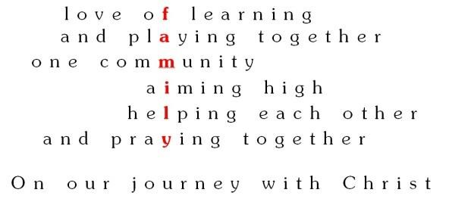
This policy also links to the school Behaviour policy and the Anti-bullying policy.
Forest school Principles
These are the principles which underpin every Forest School Session.:
- It is a long-term process of frequent and regular sessions. Planning, adaptation, observations and reviewing of the sessions are integral elements.
- It takes place in a woodland or natural wooded environment to support the development of a relationship between the learner and the natural world.
- It aims to promote the holistic development of all those involved, fostering resilient, confident, independent and creative learners
- It offers learners the opportunity to take supported risks appropriate to the environment and to themselves.
- It is run by qualified Forest School practitioner who continuously maintains and develops their professional practice.
- It uses a range of learner-centred processes to create a community for development and learning

The Forest School Leader and supporting adults will:
- Model expectations for the children. These are to remain calm, treat everyone with respect, encourage, praise and explore in a safe way.
- Proximity praise all children which are following expectations.
- To encourage and reinforce appropriate behaviour towards each other, the environment and the equipment
- To keep ourselves and each other safe during the sessions.
- To adapt and modify the session to ensure it is a positive and settling experience for all.
- To be proactive to situations by continually monitoring interactions.
- To monitor risky play whilst still allowing for growth and confidence.
- Start each session or week a fresh.

The children will aim to:
- Follow the routine as set out by the Forest School leader.
- To keep ourselves and others safe during forest school.
- Stay within the boundaries.
- To show respect, patience, calmness and to encourage and give praise.
- To not let our choices have a negative impact on anyone or anything in our Forest School.
- To explore and challenge ourselves, whilst still keeping safe.

Rewards:
A woodland wonder will be picked prior to the session, if they follow all expectations they will be named and a point given towards a special celebration session at the end of the term. If the woodland wonder hasn’t followed the expectations they will not be named and a point will not be given.

Procedure for not following expectations
Any behaviour which is not following our expectations will first get reminded of our expectations and then praised when they are seen to be following them.
If they continue to not follow, they will be asked to reflect and have explained to them as to why they have been moved away from the situation. Time will be given to them to explain the reasons for their actions. The child will be engaged with and listened to, ensuring they are told they have been listened to. After reflection, praise them for following the instructions, listen to any feelings they may share with you and encourage to reengage in the session. Praise given when they begin to reengage. Reminders are to be given if the expectations are still not followed and questions asked to see if to see if the child knows what the expectations are.

Procedure for dangerous or unsafe behaviour:
Any child showing behaviours or actions which are deemed as unsafe or dangerous are to be approached and taken away from the situation. Their actions explained to them and then an opportunity given for them to explain. This will then be referred to the Forest School lead if they are not already aware and the appropriate actions taken; this may include making SLT aware of behaviours seen in forest school
Next review: Autumn Term 2024

