St John the Baptist RC Primary School
Literacy Policy
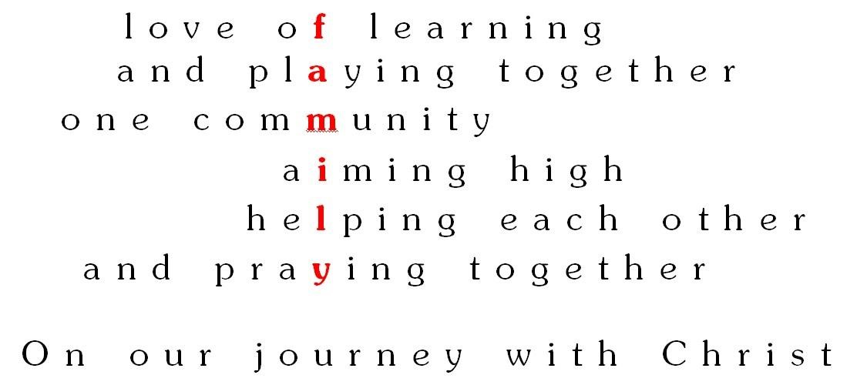

Intent
By the end of key stage 2, at St John the Baptist Primary School, we strive for all of our children to:

· be effective, competent communicators and good listeners;
· express opinions, articulate feelings and formulate responses to a range of texts both fiction and non-fiction using appropriate technical vocabulary;
· foster an interest in words and their meanings, and to develop a growing vocabulary in both spoken and written form;
· have a great interest and passion for books and to read for enjoyment, engaging with and understanding a range of text types and genres;
· be able to write in a variety of styles and forms showing awareness of audience and purpose;
· develop powers of imagination, inventiveness and critical awareness in all areas of literacy;
· use grammar and punctuation accurately;
· understand spelling conventions;
· produce effective, well-presented written work.

Teaching and Learning

Statutory requirements for the teaching and learning of English are laid out in the 2014 National Curriculum, and in the Communication, Language and Literacy section of the Early Years Foundation Stage (2014).

In order to best meet the needs of our children, we use a variety of teaching and learning styles in our Literacy lessons. We provide whole class teaching alongside opportunities for small groups to work with the teacher or teaching assistant. Some children may work with an adult to improve their understanding, and some may work with an adult to face more of a challenge, to allow for opportunities for children to delve deeper.

Our principal aim is to develop children’s knowledge, skills and understanding in language, reading and writing. At St John the Baptist, we achieve this through daily Literacy lessons that incorporate both writing and reading opportunities. Teaching styles and provision is adapted to suit the needs of the individual’s, to ensure children have the opportunity to succeed within each lesson.

In all classes, children have a wide range of literacy abilities. To provide suitable learning opportunities, teaching staff plan and deliver tasks that are matched to children’s abilities. Working walls are used to support children in their learning and to encourage independence within the classroom. Children requiring additional support receive this through small group sessions within lessons, completing work which is differentiated, in order for them to meet the objective of the lesson.

Planning for Literacy

At St John the Baptist RC, we teach using the Statutory Framework for Early Years supported by Development Matters. Our subject progression map reflects this approach. Our long term plans include the text types and writing outcomes for each year group. In terms of our medium term planning, teachers plan a ‘text based unit’ that lasts for 3 weeks. This is for staff to plan for opportunities for the children to explore their class text, unpick the author’s use of language and begin to sketch and plan their own piece of writing. SPAG is taught throughout specific paragraph lessons for children to experiment with their grammar taught and continue to practise cohesion.

Teaching phonics

At St John the Baptist RC, we follow letters and sounds. Across EYFS and KS1, children are placed in phonics groups that are delivered by teachers or support staff. Phonics lessons are daily, with a consistent structure that teaches a new phoneme a day. Children are moved into different groups if they are confidently blending and segmenting. Phonics is evident within each of the classrooms, for the children to continue to practise and apply their phonics within the wider curriculum. Phonemes are within the Working Walls and phoneme mats are available within the curriculum.

Teaching guided reading

Guided reading is extremely important at St John the Baptist RC, and it is where teachers take the time to thoroughly discuss vocabulary, ask ability appropriate questions, support children that may need extra attention, challenge the higher ability pupils and to encourage reading for pleasure. Guided reading happens every day, for 30 minutes and there is a consistent approach across the key stage. This is what guided reading looks like at St John’s. The Guided Reading is taught during a carousel cycle. Children are in guided reading groups, which each have an opportunity to do the following:

- Answer questions written by the teacher (based on the Guided Reading text)
- Answer Comprehension questions independently
- Go through comprehension questions with an adult
- Read for Pleasure
- Use the Bedrock Learning App

EYFS:
At St John the Baptist RC, we believe that developing children’ positive attitudes to literacy from the earliest stage is of paramount importance. We strive to foster these attitudes by using play, story, songs and rhymes and provide lots of opportunities and time to talk with children about their experiences and feelings. The role of adults in supporting children is crucial to fostering their positive attitudes towards Literacy and at St John’s Catholic Primary School we believe strongly that parents are our partners in achieving this.

Key Stage 1:
In Key Stage 1, children will be taught to learn to speak confidently and to listen to what others have to say. They will begin to read and write independently and with enthusiasm. The children will be encouraged to use language to explore their own experiences and imaginary worlds. Children will have daily Literacy lessons that focus on the National curriculum 2014 teaching requirements. Children will also experience daily phonic sessions to develop their reading skills.

Key stage 2:
In Key Stage 2, children have daily Literacy lessons including which include reading, writing, and spelling and grammar. Literacy skills are developed across the curriculum, with the expectation of high standards of Literacy to be applied in all subjects. Children will develop their speaking and listening skills to change the way they speak and write to suit different situations, purposes and audiences. They will read a range of texts and respond to different layers of meaning in them. Children will explore the use of language in literary and non-literary texts and learn how the structure of language works.

Curriculum Planning

Text-based units

To respond to the needs of our children at St John the Baptist RC Primary School, teachers plan around a text. From EYFS right through to the end of key stage 2, all Literacy lessons are based around a challenging text. Across the year, the texts are based on a theme such as empathy, history and geographical.This ensures that whatever part of the English curriculum that the children are learning, they are able to learn it in context. The children are immersed in the text, which also links to the year group’s topic, and this way of teaching provides the children with the opportunity to over-learn objectives. Over-learning is vital for our children at St John the Baptist and this text-based curriculum has been designed to cater specifically to their needs.

At St John’s we use the National Curriculum as the basis for curriculum planning.

Planning includes:

- A whole year overview which states the texts being used all year and how it links to the topics for that year group.
- A text-based unit plan which ranges in time scale dependent on the key stage. Literacy teaching happens in three week blocks and this is planned for in the text-based unit plan. The three week block includes a build up of: reading, reading comprehension, features of the focused genre, spelling punctuation and grammar lessons, sketching, subject knowledge lessons, planning and then ending with a final writing piece which may then be edited and improved.
- Weekly plans which break down the text based unit and is used to focus on differencing for the range of abilities within each class.

Contribution to the Catholic Ethos

I have come that they may have life, and have it to the full.
John 10:10

By preparing our pupils fully and appropriately for life in a rapidly changing and technological future, we are ensuring that they are best placed to fulfil their God-given potential and to become active and compassionate members of their local, national and global communities. Through our humanities curriculum, we teach to learn from events which have happened in the past and about how their actions can impact on the world which God has given us.

Inclusion

At St John’s, all children are involved in humanities lessons, whatever their ability, experiences and individual needs. This is in line with the school’s curriculum policy of providing a broad and balanced education to all children. Through a range of teaching and learning approaches, we enable all children to access the humanities curriculum. We strive to meet the needs of those pupils with special educational needs, those with disabilities, those with special gifts and talents, and those learning English as an additional language, and we take all reasonable steps to achieve this. For further details, see the SEND policy.

Where learning takes place outside of the classroom, we will carry out risk assessments to ensure that the activities are safe and appropriate for all pupils.

Assessment for learning

The following tools are used in the assessment of English:

- Quality marking and feedback – a pink highlighter for any mistakes and a green highlighter where work is accurate and meeting the learning objective.
- Reading book sheets – to ensure children are reading to an adult regularly.
- Reading book tracking sheets
- Phonics tracking sheets
- Optional SATs papers
- Early Years Foundation Stage assessment grids
- Frameworks guidance for Y2 & Y6

At the end of each half term, the class teacher will assess the children against the particular objectives which they have been focusing on. This will be recorded on our online tracking system, and used to make an overall judgement at the end of the year to determine if children are ‘working towards’, ‘at expected standard’ or ‘at greater depth’. This information is reported to parents on the end of year report and passed on to the next class teacher.

Monitoring and Evaluation

The monitoring of the standards of children’s work and of the quality of teaching in Literacy is the responsibility of the Literacy subject lead. The subject leader has specially-allocated, regular management time in order to review evidence of the children’s work and undertake lesson observations of Literacy teaching across the school. The subject leader will use the monitoring cycle to ensure that the subject is monitored and evaluated systematically. This also includes reporting to Governors and sharing information at the Governor Curriculum Committee.

Role of the Subject Leader

The role of the English subject leader is undertaken in line with the school policy. Subject Leaders will attend twilights and feedback during Professional Development Meetings. New ideas and resources are shared with staff as are examples of good practice within the school.

The English subject leader will:

· monitor standards of work and quality of teaching
· support colleagues in teaching of English
· ensure s/he is informed about current developments in the subject·
· provide a strategic lead and direction for the subject in the school
· organise resources to support the school English policy
· co-ordinate purchasing, organisation and distribution of resources
· arrange in-service support
· liaise with outside agencies, other schools and colleges

Monitoring and review

The subject leader will monitor teachers long term plans to ensure that all of the Literacy objectives are being covered. Work scrutiny will allow the subject leader to assess the coverage of objectives and the standard of work being produced. Lesson observations will be undertaken to ensure high quality delivery and to ensure that planning is being implemented in the classroom.

